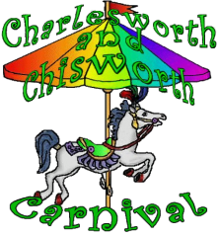

Scarecrows 2026

It’s scarecrow time! In recent years we have been doing colour themes, think we’ve done most of them now. Time for a change of tack. This year the theme is Christmas, that’s right Xmas in summer.
You can be literal or cryptic it’s totally up to you. You could do Aussie Xmas dinner BBQ, Santa sunbathing (I think we had one of those a couple of years ago) or get the tree out of the attic and go full on Christmas eve at home. We’ve had some great interpretations of themes in recent years, with lots more people taking part and I can’t wait to see your amazing creations.
Rules:
We need to be able to see your creations so at least 1m tall, safely erected and visible from the pavement (unless you want people in your garden).
Appropriate for display (keep it PG please).
Your scarecrow needs to be up by 4th July and for 2 weeks.
To enter, either, print and fill in this form and return to 9 Green Bank, Simmondley or message the carnival Facebook page with the entry details below. You will receive a sign to display and your location will be on the Scarecrow Map.
Voting: only on the day by visiting carnival HQ on the field. Winners will be announced on carnival day 11th July.
Thank you for being part of carnival 2026.
Entry details:
Name and Address Scarecrow name

